# Precision Mold Manufacturing for Life Science Devices

# Introduction

Life science industry encompasses several aspects of healthcare and medical sciences like pharmaceuticals, biotechnology, medical devices, digital health, etc. This industry is involved in the development and manufacture of different life science devices with an aim to produce innovative treatments, diagnostic tools, and equipment for the improvement of human lives and patient care. Plastic injection molding is instrumental in producing large quantities of high-quality, durable, accurate, sterilization-friendly medical-grade plastics and products. Such generated products are crucial for the improvement of patient care and lives, advancement of medical research, and innovation in life sciences. So, the article focuses on the important role of life science devices and the indispensable function of plastic injection molding for the development of life science devices. This article further includes content like material selection, injection molding process, design considerations and customization, quality control and validation, and market trends and future innovations in life science devices.

# Crucial role of life science devices

Life science devices play a pivotal role in different sectors of health and medicine improving the health of patients.

1. Pharmaceutical industry: Different life science devices like automated liquid handling equipment, inspection equipment, cell culture equipment, etc. have been constantly used in drug discovery and development, and testing. It leads to the development of new pharmaceuticals and therapies like precision medicine (personalized medicine).

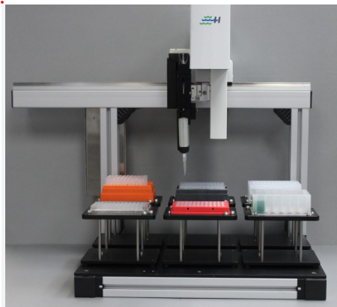

Figure 1: Automated Liquid Handling Equipment (<https://www.biotronhealthcare.com/automated-liquid-handling-systems/>)

1. Disease diagnosis and monitoring: Life science devices are crucial in precise and early disease diagnosis and treatment. For example, biosensors are applied for disease detection, retinal prostheses, contrast imaging during MRIs, heart diagnosis, etc.

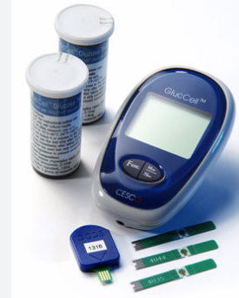

Figure 2: Biosensors (<https://biosensortechnology.weebly.com/examples.html>)

1. Therapeutic and surgical instruments: Therapeutic devices like arthroscopy, electro-medical equipment, ultrasounds, medical lasers, etc. are used for preventing, diagnosing, monitoring, and curing diseases. Utilization of high-precision surgical instruments and robot-assisted devices assist in improving the accuracy and effectiveness of surgeries. For instance, the Bitrack surgical robot improves the efficiency of minimally invasive surgery.

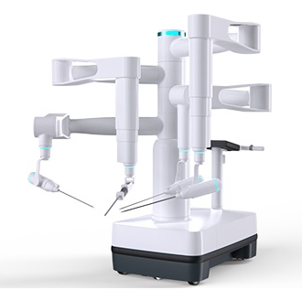

Figure 3: Bitrack Surgical Robot (<https://www.surgicalroboticstechnology.com/company/rob-surgical/>)

1. Research and Development: Life science devices are continuously used in the study of cellular, molecular, and physiological processes, gene expression, DNA sequencing, etc. It can be useful in disease diagnosis and monitoring, and the development of drugs and therapies. Likewise, such research leads to the development of innovative treatment procedures. Utilization of innovative technologies like digital health services, robot-assisted devices, remote monitoring, etc. enhances the precision and efficiency of the medical sector.

# Material Selection for Life Science devices

Suitable material selection is critical during product development for medical devices and instruments. So, the following important factors should be considered.

1. Material properties: The performance properties of materials should be taken into account while selecting materials for medical devices. For example, PEEK demonstrates excellent mechanical, chemical, and high-temperature resistance properties, therefore used for medical pumps and implantable.
2. High-temperature performance and radiation resistance: The material should be resistant to high temperature and radiation to withstand repeated sterilization procedures and allow uninterrupted cleaning purposes. For example, polycarbonates with high strength and can be sterilized both with stream and gamma radiation is used in tubing, high-pressure syringe, cannulas, etc.
3. Chemical resistance: Materials should be non-reactive to chemicals in order to ensure the integrity of the product and manufacturing processes. For instance, PTFE is chemically resistant with a low coefficient of friction and can withstand a broad temperature range. Therefore, it is ideally utilized as a catheter liner.
4. Biocompatibility: This is the most important criterion to be considered for material selection to avoid negative impacts on living tissue and the environment. It also very important for the development of implantable medical devices, internal prostheses, and procedures.
5. Regulatory compliance and standards: Life science devices require plastic materials that meet a variety of compliances like FDA, USP class VI, ISO 13485, and ISO 10993 for the manufacture of medical devices.

Other factors include:

1. Design flexibility
2. Lightweight
3. Hydrophobicity
4. Welding properties
5. Cost-effectiveness

# Injection Molding Process for Life Science Devices

There are different types of injection molding processes used in the manufacturing of life science devices.

1. Plastic injection molding: Various medical-grade plastics are used for medical injection molding: polyetheretherketone(PEEK), polyethylene, polycarbonate, polypropylene, silicone, polystyrene, etc. The process involves the injection of melted plastic through a heated and pressurized nozzle into the temperature-controlled melted mold. Then the part is ejected when it cools down and the mold opens. Then after, the mold closes and the process repeats.

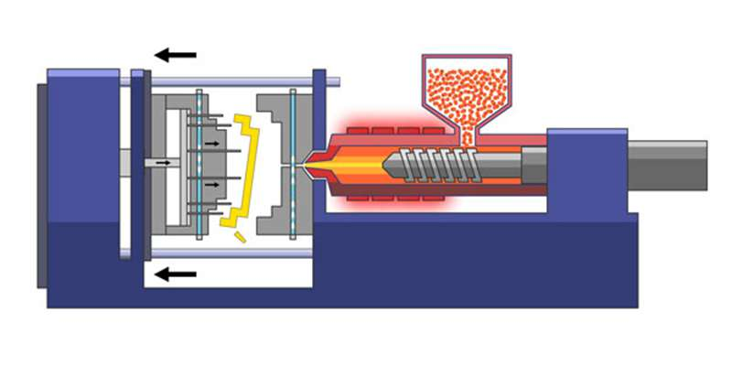

Figure 4: Plastic injection molding process (<https://www.aireplastics.com/basic-injection-molding-process/>)

1. Overmolding: It is the process that molds a polymer over a substrate. Generally, thermoplastic elastomers (TPE) are molded over rigid thermoplastic substrates reducing the production time and the cost. It helps in the development of products with improved grip and ergonomic features. Several surgical instruments, diagnostic equipment, and drug delivery systems are manufactured with the application of plastic overmolding.

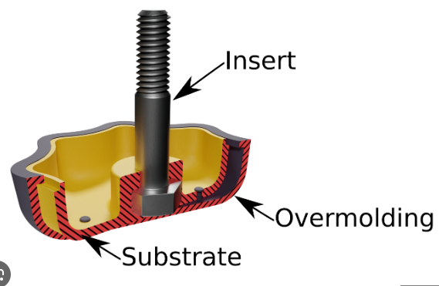

Figure 5: Overmolding Figure 6: Overmolded Medical Devices

(<https://shorturl.at/jqIJ6>) (<https://shorturl.at/hoHPZ>)

1. Gas-assisted injection molding: In this process, a pressurized gas (generally nitrogen) is injected into the molten plastic melt stream. The gas produces bubbles that molten plastic into the mold’s extremities leaving hollow tube-like sections. When the mold completes, the gas is exhausted from the inside of the product and the parts are removed. It improves the product design flexibility, strength, and rigidity, reduces the weight and production cost, and produces smooth and extremely cleanable parts. It is used in the manufacture of side panels and covers for medical devices.

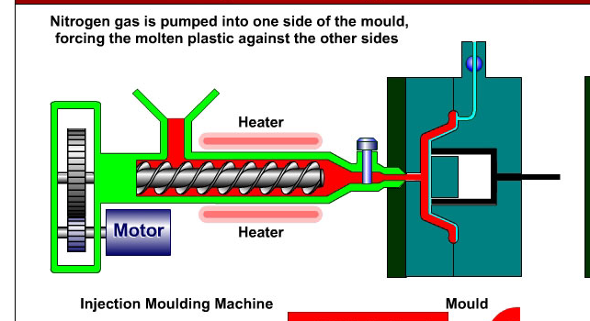

Figure 7: Gas-assisted Injection molding

(<https://www.notesandsketches.co.uk/Injection_Moulding_Gas_Assisted.html>)

1. Liquid Silicone Injection molding: This injection molding is quite popular these days. The process involves injection of liquid silicone into the mold cavity. The silicone solidifies formina flexible component tak Examples of silicone medical devices are balloon catheters, compression bars, connectors, seals, gaskets, impellers, syringe stoppers plugs, etc. This molding process improves the performance, quality, and durability of the product.

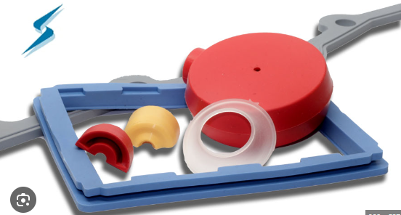

Figure 8: Liquid silicone injection molded medical devices (silicone gaskets and cushioning pads)

(<https://www.stockwell.com/blog/silicone-gaskets-and-cushioning-pads-for-medical-applications/>)

**Advantages of injection molding in precision**

i) Utilization of advanced equipment and precise measurements.

ii) Production of complex plastic components.

iii) Precision and consistency

iv) Reliable and consistent production

v) Production of biocompatible, durable, versatile and sterilization-tolerant plastic components.

vi) Rapid production of defect-free parts.

vii) Reduced cost of production and risk of contamination

viii) Reduction of labor cost and waste production

ix) Improvement in the quality and performance of the final product.

# Design Considerations and Customization

**Design Considerations and Principles**

1. Design for Manufacturing: It is a critical criterion to be considered. It involves several factors i) the selection of the right materials and the right manufacturing process, ii) the utilization of different art design principles, and iii) investments in different technologies. That’s why you should integrate Design for Manufacturing into the production of plastic injection molding products.
2. Material selection: Following properties should be considered based on the requirements of the product.
3. Biocompatibility
4. Sterilization tolerance
5. Chemical resistance

Medical-grade plastics can be utilized for medical injection molding.

1. Versatility: Manufacture of versatile plastic components should be prioritized. These components can be utilized for diverse purposes.
2. Safety: The manufactured products for life science devices should be user-friendly. It should assure the safety and comfort of the users.
3. Resilience: The components should have the potential to withstand rigorous use and diverse environments without change in their properties.
4. Adherence to quality standards and regulatory requirements: The materials used for the molding process and the devices generated must meet the regulatory standards and quality assurance requirements. It eliminates the risk of failure and poor functionality during medical procedures.

**Significance of accuracy and detailing**

Uniform and precise production of medical device components can be ensured. It reduces the risk of inaccurate results and complications during medical procedures. It also increases the lifespan of manufactured medical devices and reduces the cost of repair and maintenance. Further, the products with high precision ensure patient safety. It also improves the efficiency and effectiveness of devices with reduced human error and hence can be utilized in health care research and activities.

**Customization possibilities**

It provides opportunities for the production of customized medical devices. Different medical tools like surgical, therapeutic, and lab tools can be redesigned and produced based on the requirements of the devices and the treatment. Similarly, patient-specific tools like auricular splints, dentures, orthodontic appliances, orthotics, and prostheses can be developed based on the patient’s needs.

**Design flexibility and innovations in life science devices**

Due to the design flexibility of injection molding, it has a plethora of opportunities for innovation in life science devices. Different highly precise components can be developed that leads to better health outcome and patient care, improved patient satisfaction, and cost-effective health care systems. Different customized medical and lab tools can be designed and produced on a large scale based on the requirements of the patient and treatment. For example: lightweight, durable, and cost-effective prosthetics and orthotics with enhanced mobility that match an individual patient’s anatomies are being produced. Likewise, microfluidic devices have revolutionized the health sector with their contribution to precise diagnosis and drug delivery systems and other various laboratory processes.

# Quality control and validation

It involves careful testing, documentation, and adherence to regulatory standards.

1. Design test: Design should be verified through analysis and testing to prevent failure at early stages
2. Material selection: Material should be selected for medical devices that satisfies biocompatibility testing and sterilization compatibility
3. Validation and verification. The injection molding process should be verified to meet design requirements. Quality assurance and validation of equipment used in the manufacturing process should also be done.
4. Functionality testing: Newly manufactured devices should be checked to ensure their accurate functioning.
5. Post-marketing assessment: Regular monitoring and reporting of the functioning of the devices should be carried out. It assures the durability and reliability of the devices.
6. Medical standards and certifications: Medical standards and certifications ensure that the device are reliable enough for patient usage.
7. Testing and inspection: Regular monitoring and inspection of the manufacturing process should be carried out. Final devices should also undergo inspection to ensure they meet quality standards.

# Market Trend and Future Innovation

The global medical devices market is expected to grow at a compound annual growth rate of 5.5% from 2022 to 2023, whereas its value to reach USD 850 billion by 2030.



Figure 9: Medical devices market trend (<http://surl.li/mvsqy>)

The advancements in smart technologies and sophisticated instruments have significantly improved remote health monitoring. For example: wearable sensors track patients’ health status and a variety of health-related functionalities. Likewise, implications of the Internet of Things (IoT), artificial intelligence, robotic automation process, datafication, 3D printing, edge computing, virtual reality and augmented reality, real-world data, genomics, and blockchain technologies have been emphasized in the assessment of patient’s health status. The COVID-19 pandemic enhances the importance and adoption of telemedicine. Further, personalized medicine, customized implants, prosthetics, and drug delivery systems can be developed with the utilization of emerging technologies.

However, the life science sector has been facing several challenges: strict regulatory standards that increase the cost and time for new medical devices to reach the market. Likewise, maintenance of data privacy and security has also been a threat, so the companies that can address such issues have a good opportunity in the market. Integration of the healthcare sector with other emerging technologies and the global market has potential advantages.

# Conclusion

To sum up, plastic injection molding is a privileged technique for manufacturing a variety of life science devices. However, precision in material selection and manufacture of life science devices is crucial therefore must be considered. It ensures that the devices are safe, effective, and compliant with regulatory standards. Any malfunction in the devices can cost the patient’s life and ineffective treatment. On the other hand, adherence to quality standards helps to minimize the cost of production and risk reduction. Therefore, precision and maintenance of stringent standards are key to success in the advancement of the life science industry.